Jennifer Fischer
Student ID: 011115446
D197 – Version Control

A1: Create Branch
Created a branch named ‘Working’ in the D197 Version Control Repository
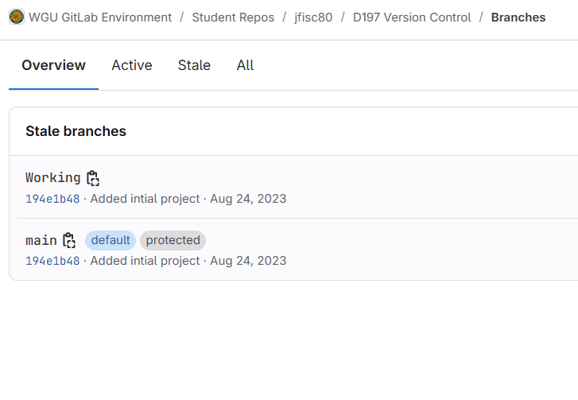

A2: Repository Graph Screenshot
First Repository Graph after ‘Working’ branch was created
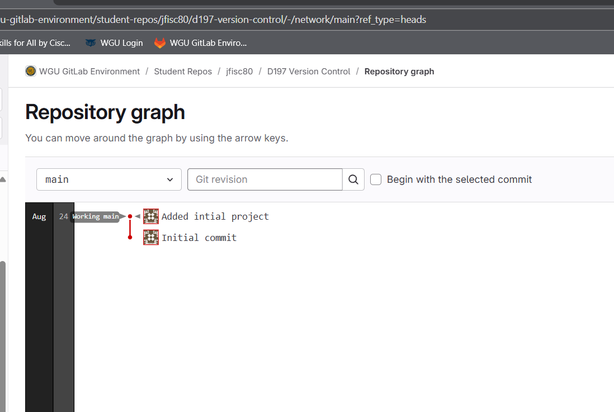

B: Cloning Remote Repository
Cloned the remote repository on the local machine
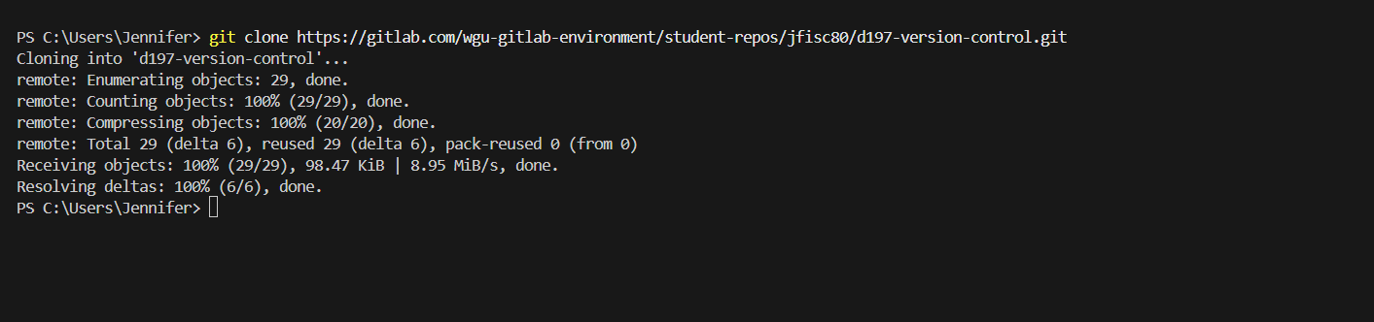

C1: Commit with a message
Modified 3 HTML files on the Working branch; committed to push to the remote repository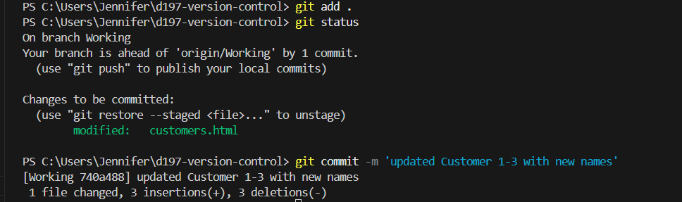
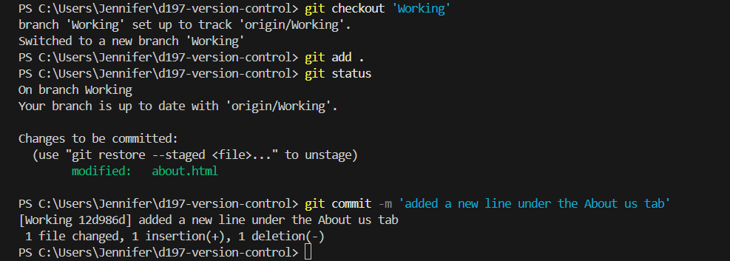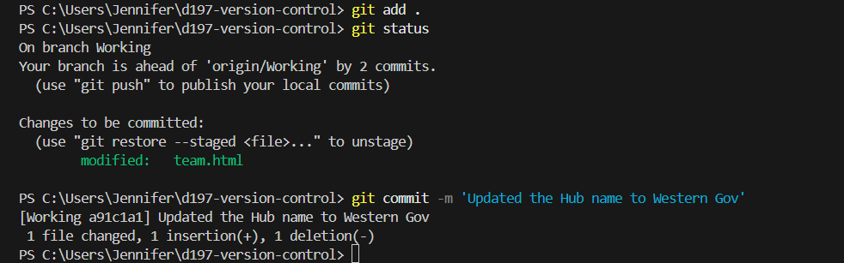

C2: Push to Remote
Pushed the HTML file changes to the remote repository
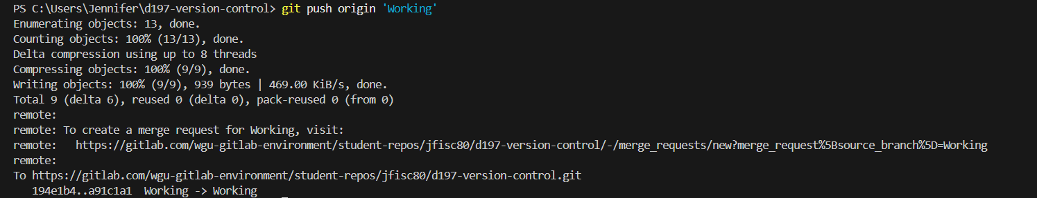

D: Modify a File
Created a new branch locally ‘Test’, added my student ID to the README file, added and committed and pushed to the remote repository
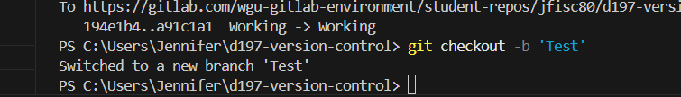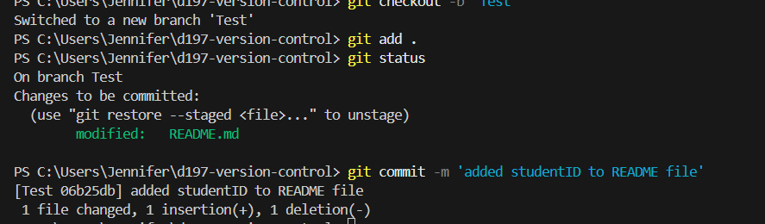
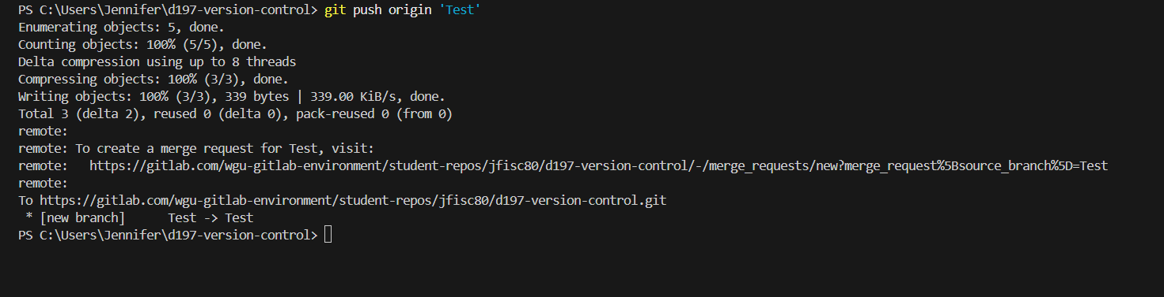

D1: Proof of Remote changes
Repository Graph showing the creation of the Test branch and the added changes to the README file
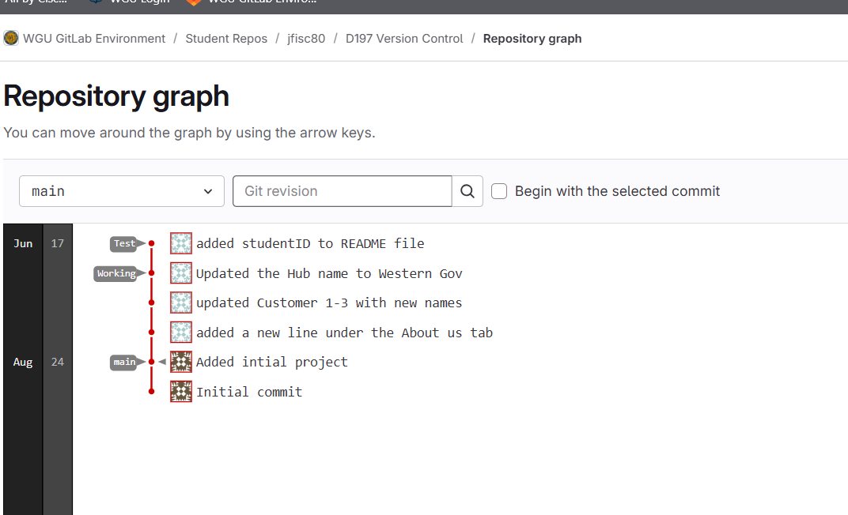

E: Introduce a Merge conflict
Added the git version to the Working branch README file, added, committed, and pushed to the remote repository. Merged the Test branch with the Working branch. A Merge conflict was created on the Test branch and rectified.
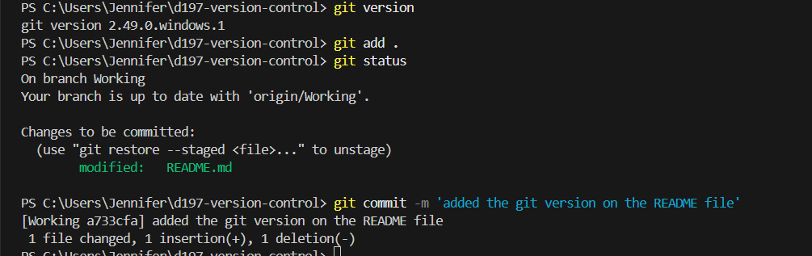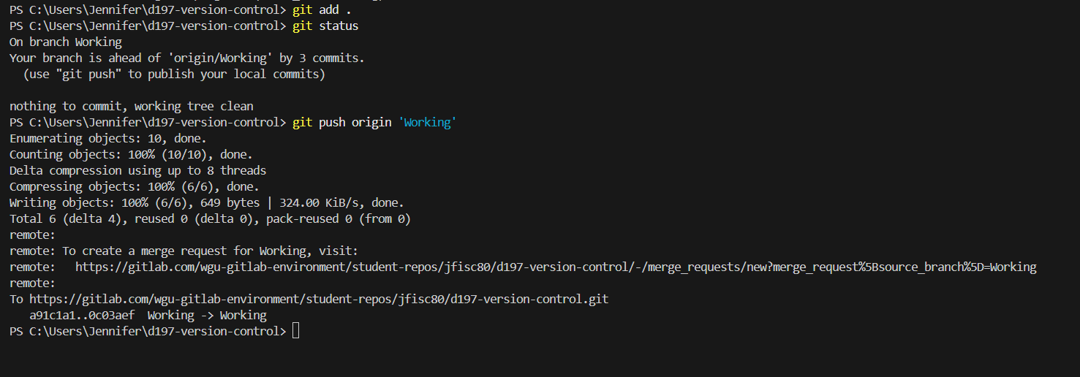
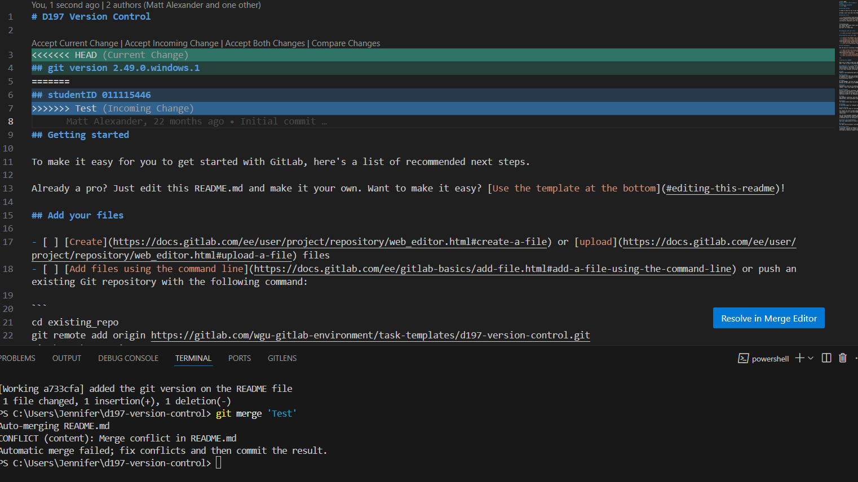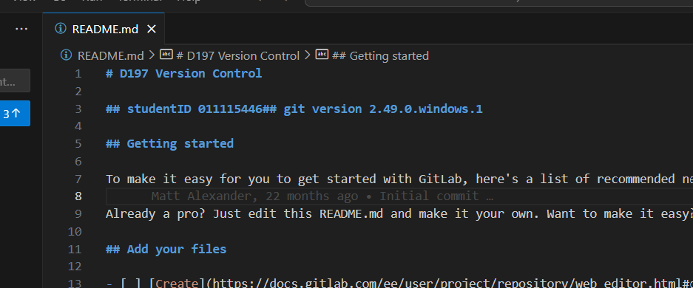
E1: Resolution and proof of remote changes
Showing the remote repository with the pushed changes
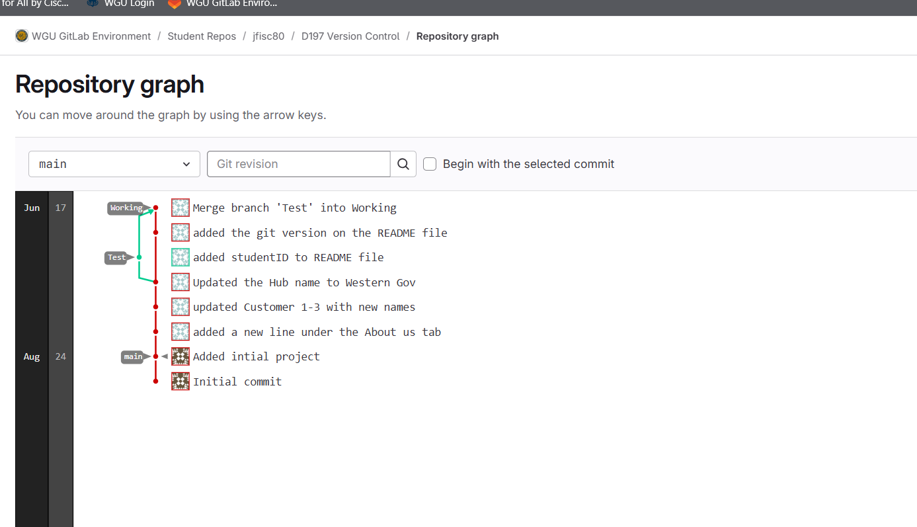

F: Tag Working Branch
Created a tag for the Working branch
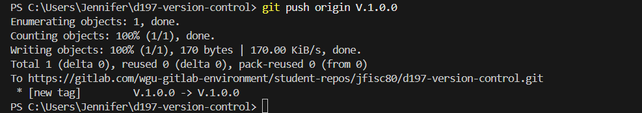

F1: Proof of remote changes
Graph repository showing the tag on the Working branch
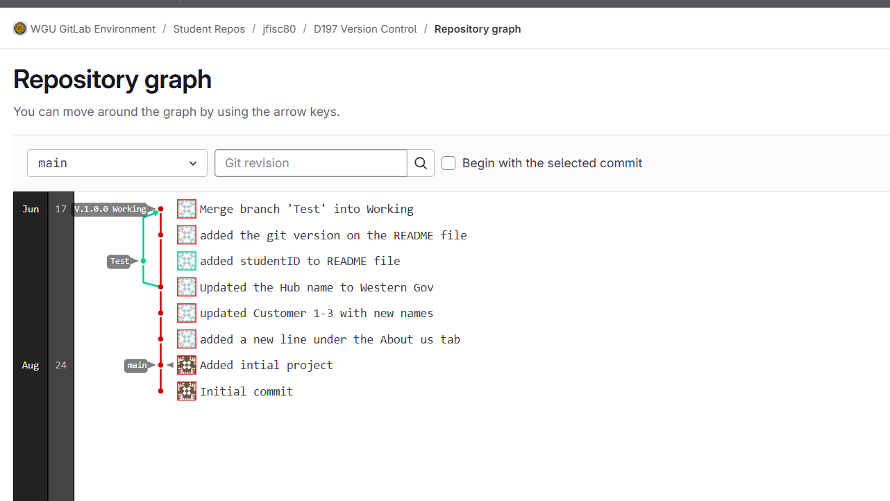

G1: Retrospective Directory
Retrospective directory was built on the Working branch
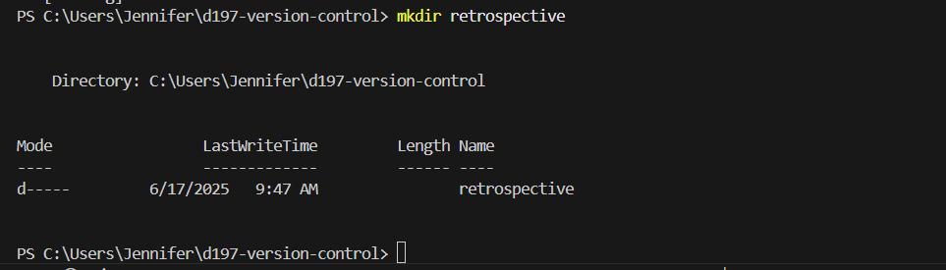

G2: Log.txt file
Created a text file in the Retrospective directory on the Working branch
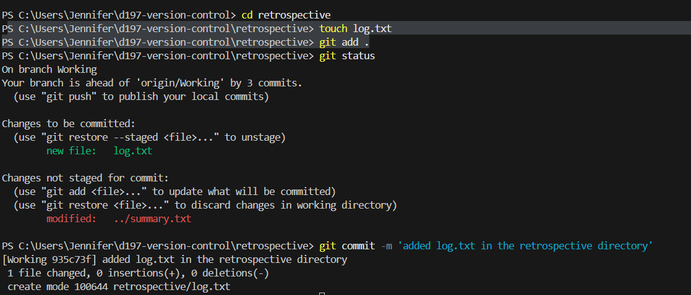

G3: Summary.txt
Created another text file in the Retrospective directory on the Working branch
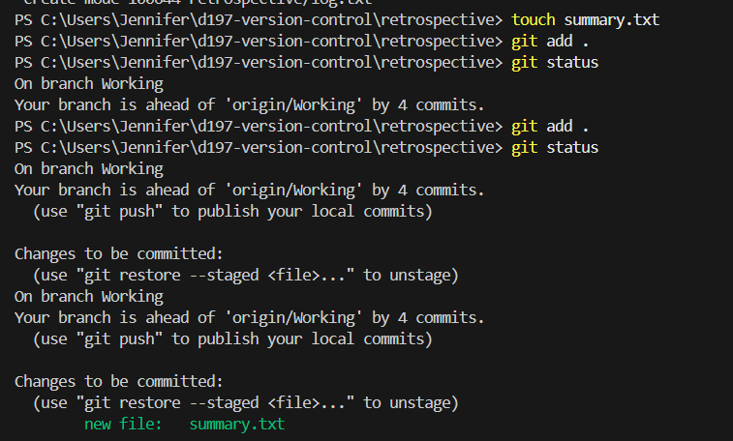
G4: Word Document created with Screenshots
Moved the document into the Retrospective directory

